Connor Downs Academy
EYFS Home Learning Guidance – Phonics
Phonics (15-30 minutes, daily)  Continue to revisit and revise the Phase 2 and 3 sounds of Letters and Sounds. These sounds are:  Phase 2:  Set 1: s, a, t, p  Set 2: i, n, m, d  Set 3: g, o, c, k  Set 4: ck, e, u, r  Set 5: h, b, f, ff, l, ll, ss  Phase 3:  Set 6: j, v, w, x  Set 7: y, z, zz, qu  Special Friends (Consonant Sounds): ch, sh, th, ng  Special Friends (Vowel Sounds): ai, ee, igh, oa, oo, ar, or, ur, ow, oi, ear, air, ure, er  The taught word/rhyme that accompanies each of these sounds can be found in the phonic packs attached.  Aim to pick 1 focus sound each day and practise reading the sound. Can your child remember its accompanying word, rhyme or story? Can your child recognise and read the sound in a range of contexts, such as in different sentences? | Phonics  Tricky Words and High Frequency Words  Continue to revisit and revise the tricky and high frequency words learned so far. Remember to try and read the tricky words on sight, as they are not fully decodable. I have included the new Phase 4 tricky and high frequency words for you to learn when you are ready.  Phase 2 Tricky Words: I, no, the, to, go into  Phase 3 Tricky Words: he, she, we, me, be, you, are, her, was, all, they, my  Phase 4 Tricky Words: said, have, like, so, do, some, come, little, one, were, there, what, when out  Phase 2 High Frequency Words: a, dad, I, mum, big, it, at, is, on, up, back, if, but, of, into, his, to, him, had, in, no, got, the, go, an, as, can, off, not, get, and  Phase 3 High Frequency Words: will, that, then, now, she, this, with, for, he, them, down, me, my, see, too, was, all, look, we, you, her, be, they, are  Phase 4 High Frequency Words: went, from, children, little, it’s, just, help, said, were, out, like, one, have, do, when, some, come, there, what, so | Phonics  Online Resources and Additional Guidance  https://new.phonicsplay.co.uk  Username: home  Password: march20  https://home.oxfordowl.co.uk  Create a free account to access free eBooks that link to your child’s book band. Can you complete the linked activities for each book?  Please continue to read a variety of books at home. Favourites can be repeated. Hearing the patterns of language in a story will support your child’s language development.  You could also look in magazines, newspapers and books for the tricky words and high frequency words. You could encourage your child to use a highlighter to highlight these words in the magazines and newspapers you share together.  Remember, at school, phonics sessions typically last for a duration of 15-30 minutes. However, if your child is feeling particularly enthusiastic about their learning and would like to access your chosen activities for slightly longer periods of time, then that is equally fantastic.  As many of you will already know, there are a fantastic range of online resources and virtual lessons which can support your child’s learning of phonics at home. Please continue to access these as you wish, at a pace that suits both your child and your home circumstances.
Maths (15-30 minutes, daily)  Focus: Numbers 11-15  Watch a Numberblocks clip each day. You can assess these clips through either the BBC or CBeebies.  This guide will help you to support your child’s learning whilst watching an episode of Numberblocks at home.  Create visualisations of teen numbers using natural objects and resources. For example, when thinking about 12, you could use a stick to represent the ‘tens’ and 2 apples to represent the two additional ‘ones’ added. 12 = 10 + 2.  Starting from 0, practise counting up to 20 and beyond 20. This could be done through playing hide and seek, singing number songs, chanting and board games. Remember to ensure that your child is pronouncing all of the number names correctly, particularly the teen numbers.  Practise writing the digits 0 – 9. Please support your child in forming these correctly by modelling the digits as needed. If you can do this, can you write the numbers 10 – 20 independently?  Practise subitising (recognising amounts) by listening to The Subitising Song and playing this game. You could also subitise by reading a dice when playing board games, playing with cards, or even by recognising how many items of food are on your plate. | Task A – Fairy Tale Writing Challenge  Please Upload to Tapestry  Choose your favourite fairy tale character and create a picture, collage or model of them. Can you try and write a short sentence or a story about your chosen character?  You could support your child by helping them to formulate a simple sentence and then encouraging them to sound out the words that they will need to write. For example:  My favourite character is Goldilocks.  my (tricky word) f-ai-v-r-i-t (favourite) c-ar-i-c-t-er (character) i-s (is) g-oa-l-d-ee-l-o-x (Goldilocks).  my faivrit caricter is goaldeelox  Please remember to allow your child to write their words phonetically, as this well help them to learn. | Task B – Small World Challenge  Please Upload to Tapestry  Can you use a range of resources to create a scene or setting from your favourite fairy tale or nursery rhyme? If you can’t choose a favourite fairy tale, you could create a small world scene or setting linked to a story of your own interest.  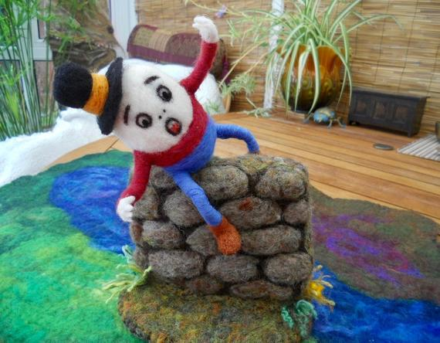  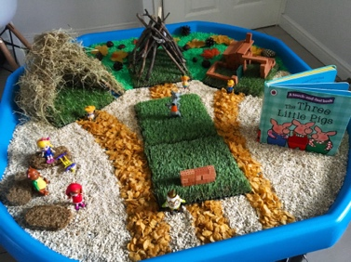  You could support your child by encouraging them to discuss their ideas with you.
 | Task C – Playful Learning Challenge  Please Upload to Tapestry  Play is the key to learning, both at school and at home. Through their playful learning, your child will continue to develop key skills such as inquiry, expression, experimentation and teamwork. Take this opportunity to play alongside your child and see where their imagination can take you!  You could support your child by allow them to lead the play, and by responding to their ideas and instructions. You could use ‘I wonder how/what/when/where/why?’ questions to help deepen your child’s thinking.  Please feel free to use Tapestry to share as many examples of your child’s playful learning as you wish. | Task D – Magic Potion Challenge  Please Upload to Tapestry  With an adult, can you combine a range of ingredients to create your own magical potion? Once you have created your potion, you could share a video on Tapestry, explaining what your potion does, which ingredients you chose and how you made it.  You could support your child by modelling mathematical vocabulary, such as: solid, liquid, full, half, empty, measure, compare, volume, capacity. You could also encourage them to create a range of magical potions, each with a different purpose or power. For example, a gold potion that makes you rich and a green potion that turns you invisible.

