Connor Downs Academy
EYFS Curriculum Enhancement Plan

Term: Autumn 2 | Year: 2019/2020 | Teacher: Mr Masters  TA: Mrs Malyan | Focus Texts: What Makes Me a Me?, See Inside Your Body, All Are Welcome, Funnybones
Curriculum Enhancement Focus: All About Me
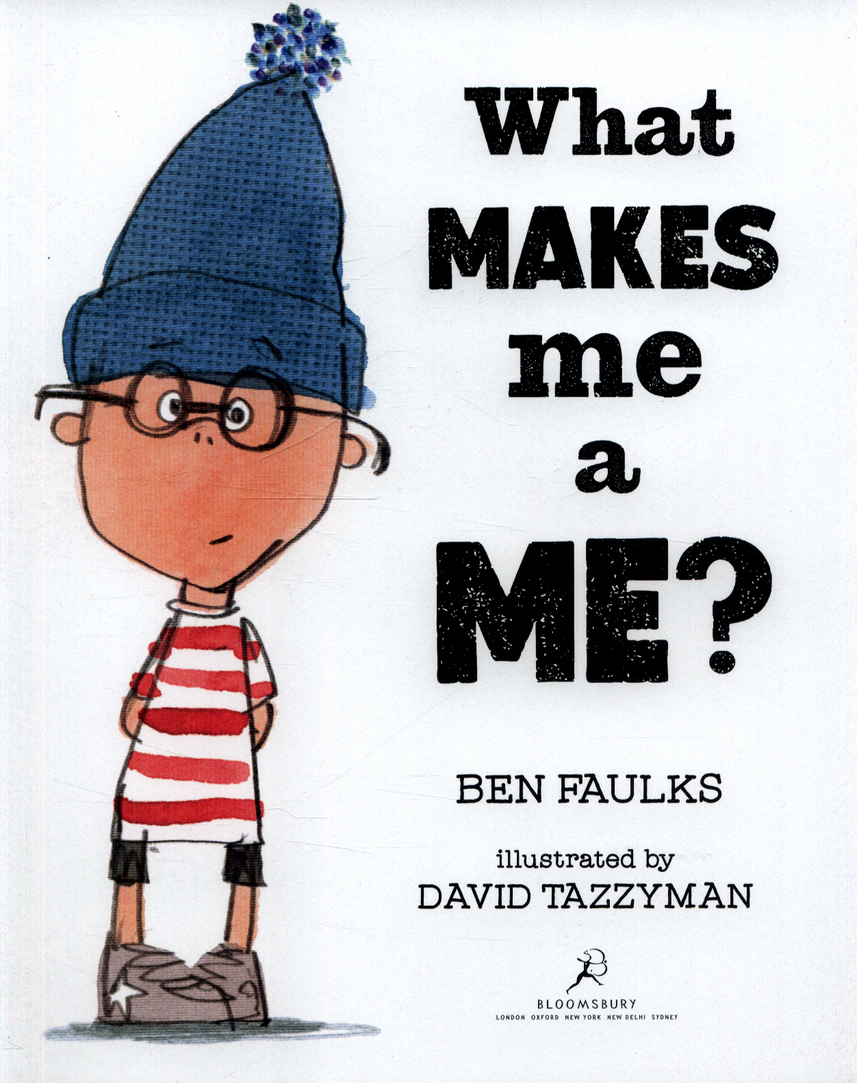
Personal, Social and Emotional Development:
- Establish and discuss the importance of diversity, mutual respect and tolerance; why is it important to celebrate our differences and foster kindness? Circle time – ‘All Are Welcome’.
- What are the differences between kind choices and unkind choices? Does making unkind choices make you an unkind person?
- What makes you special and why? Circle time – ‘What Makes Me a Me?’
- Why don’t we all look the same? Circle time.
- ‘Stop, I don’t like it.’ – explore emotions and what they mean.
Communication and Language:
- Home corner role play; can you introduce a reflective storyline or narrative into your play?
- Doctors role play; can you use accurate vocabulary to name and describe various parts of your body?
- Emotion stones and emotion texts; can you explain and/or describe how you are feeling?
- Story time reflections; can you answer key questions about the focus texts, using more complex sentences to link your thoughts?
- Play ‘Guess Who?’, encouraging the use of descriptive language to identify the chosen child. Can you link your ideas together?

Literacy
- Can you write labels for different parts of your body, using initial sounds?
- Can you match the names of your classmates to the correct initial sounds?
- Can you create a story wherein you are the main character? Can you use marks, pictures, labels and/or captions to enhance your story? Can you tell your story to a friend/adult?
- Draw a picture of yourself and who is special to you, writing labels to identify each person.
- Find the letters of your name in a range of media, e.g. newspapers and magazines, cut them out and stick them in the correct sequence to write your name.
Physical Development
- What happens to our bodies when we exercise?
- Can you find your heart? What does it do?
- Play ‘____ says’ to showcase talents/skills and teach your friends.
- Can you use your fine motor skills to create a self-portrait using loose parts?
- Explore different ways of moving and balancing, using different parts of the body.
- Think about and practise methods of personal hygiene; how you can keep yourself healthy and safe?
- Button, zip and lace station.

Expressive Arts and Design
  - Play with and add dialogue to small world provision – creating scenarios and stories reflective of your own experiences.
  - Cut up newspaper/magazine images and combine them to create a new person, representing different people and cultures.
  - Use colour, texture, shape, form and space in two or three dimensions to make a representation of either your geographical location or of the globe.
  - Use mirrors and photographs to create a self-portrait, thinking about your unique features and characteristics.
  - Make a representation of your body, using cocktail sticks as your skeleton and playdough as your skin.
  - Learn and perform songs and rhymes linked to British Values, identity and the human body, e.g. ‘Heads, Shoulders, Knees and Toes’.
Understanding the World
- Investigate and name different parts of your body.
- Use a range of resources to identify explore your geographical location.
- Consider how we change over time, from birth to now.
- Use a pictorial, chronological timeline to discuss how you have changed over time, from birth to now.
- Compare and discuss the similarities and differences between ourselves and children in different parts of the world.
- Develop an understanding of other cultures and faiths.
- Discuss and describe toys/objects from the past, comparing them to toys/objects from the present.
Mathematics
- Maths is all around us; can you spot/create the number of the week in your surrounding environment?
- Create a chronological timeline of your life, writing the numerals 0-5 correctly.
- Can you use a tape measure to compare your height to a friend’s? Who is shorter/taller? How do you know?
- Order shoes from smallest to largest; which of your friends has the smallest/largest feet? How do you know?
- How many bones does the skeleton have? Can you use the model/image to count the total amount?
- Can you use playdough to create the numeral that matches your age?

